Access, stage left: Bringing the hearing-impaired back to the theater
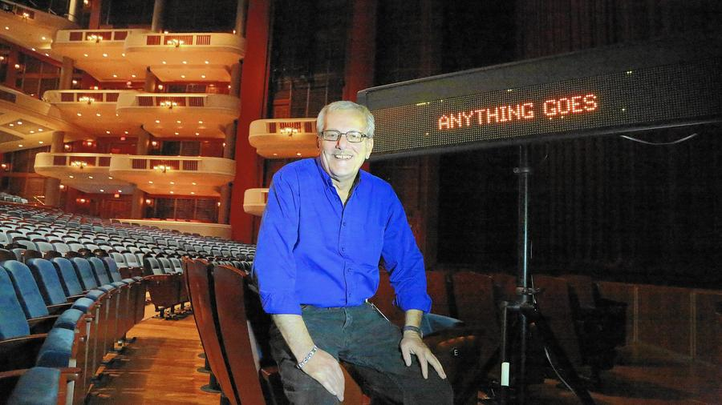

Lew Balaban does captioning for all the big Broadway shows that come to South Florida so that the hearing-impaired can enjoy them. Lew was photographed at the Broward Center for the Performing Arts.
(Carline Jean / Sun Sentinel)
By Rod Stafford Hagwood contact the reporter
- Billy Crystal
- John F. Kennedy Center for the Performing Arts
FLACA opens up the performing arts to #impaired audiences in South #Florida.
Access to performing #arts opened to audiences by #FLACA.
@browardcenter, @KravisCenter, @ArshtCenter open #theater up w/ #FLACA.
If you've been to a Broadway show in South Florida in the past five years, it's probably been right there in front of you, and you might not have noticed.
Open theater captioning for hearing-impaired and deaf audiences is a feature at Broward Center for the Performing Arts in Fort Lauderdale, Kravis Center for the Performing Arts in West Palm Beach and Adrienne Arsht Center for the Performing Arts in Miami. The discreet screen, off to the side of the stage in the orchestra seating section, provides a written description that includes dialogue and lyrics. The service is managed by the Florida Access Coalition for the Arts (FLACA).
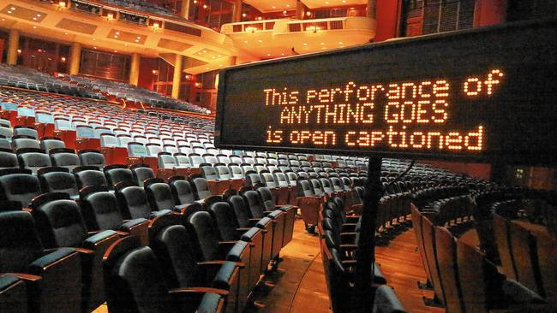

Florida Access Coalition for the Arts provides captioning for Broadway shows at the Broward, Adrienne Arsht and Kravis centers for the performing arts.
(Carline Jean / Sun Sentinel)
"People need to know these services exist," says Lew Balaban, a founder of FLACA. "The last show of the season at Kravis — it was 'Flashdance' — the display broke. People streamed out to the lobby to find out what happened. Kravis had no idea that there were that many people there for the captioning. Not a clue."
Open theater captioning started in South Florida six years ago with the road-tour run of "The Phantom of the Opera" at the Broward Center. "They held a sort of focus group of the hearing-impaired and deaf," Balaban recalls. "All eight [people] came out hugging and crying and saying, 'Thank you. We can enjoy theater again.' I left the theater shaking I was so moved."
Now, with 30 full-time members, FLACA also works with museums, operas and ballets to provide captioning, audio descriptions, sign language, large-print and Braille scores and touch tours.
Garry Novick, senior manager of guest services at Fort Lauderdale's Parker Playhouse (which is managed by the Broward Center), explains the popularity of the theater captioning: "A lot of people attend theater for a good part of their life and, for one reason or another, they stop. Perhaps their hearing diminished or went away completely. We had one individual who actually bought the scripts. But then, it was too much, flipping through the script and looking up. And to quote that person, 'That's when the light from Broadway went out for me.' But with captioning they said, 'And like the light, I'm back.' They were so excited. This has happened for so many people. You can imagine how important open theater captioning is. It brings them back to the theater."
For the shows at the Broward, Kravis and Arsht centers, Balaban sits at house right (stage left) with his laptop. There is a small screen just in the sightline of the audience members as they look toward the stage. The performing arts centers reserve a number of seats expressly for this purpose.
cComments
Got something to say? Start the conversation and be the first to comment.
Add a comment
0
The process for Balaban, who is a court reporter by day and performed in "Hair" on Broadway in 1972, starts before the road tour even gets to town.
"I get the script and transfer it into captioning software," the Fort Lauderdale resident explains. "Then, I go back and format the show — the pauses, overlapping lyrics — the best I can, strictly guessing. Then, I go to the preview and mark up the script looking at the performance. Then, if I'm lucky enough to have a show with a second preview. I tighten it all up. Sometimes, an understudy will go on, and that might change things. Kravis and Arsht have shorter runs, so I really have to scramble.
"And then, there are shows like 'I Love Lucy' or 'Spamalot,' that's where the court reporting comes in handy because they did some audience participation parts and that changed every night. Mostly, I just have to hope they stay on script. Remember that Agatha Christie murder mystery play that came to Parker Playhouse ["Agatha Christie's the BBC Murders"]? Well, Gary Sandy, that guy from 'WKRP in Cincinnati' couldn't remember his lines. That was awful. Every night, he said something different."
Balaban says other difficult shows to caption include "My Fair Lady" ("lots of quick back-and-forth dialogue and overlapping lyrics"), "Come Fly With Me" ("everyone thinks they know Sinatra's lyrics") and Blue Man Group ("are you kidding me? No dialogue, just sound effects and mime stuff").
"In 'Billy Elliott,' no one could understand that accent, that Geordie accent," Balaban says. "We had more people looking up at the screen than ever. I don't think they were hearing-impaired at all. They just wanted to know what they said in the show. If I didn't have the script, I wouldn't have known."
One of his favorites: "In Chita Rivera's one-woman show, she kept looking at the display to figure out what she was supposed to be doing."
Not one of his favorites: "Billy Crystal refused. It was awful. He was adamant. Now, we have what we call a 'Crystal clause' that says some of the performances will be accessible."
Novick says he's overheard audience members in the lobby after a show say that they had been singing the wrong lyrics to some of their favorite Broadway shows. "A lot of people don't self-identify as having any loss of hearing," he says.
Balaban agrees, adding, "It's an invisible disability. People don't like to admit it. They turn the TV up or they speak a little louder."
He is quick to distinguish between open theater captioning and closed captioning for television. "[TV is] verbatim," he says. "[With opera], it's the essence of what they are saying or are singing. Whereas with a show, or especially a play, you really care what they are singing or saying. So when they pause, I pause. When they hold a note, I show that."
FLACA grew out of the Kennedy Center's LEAD (Leadership in the Arts and Disability) conference in 2009. Two years later, FLACA returned to the conference and presented a workshop on how to successfully regionalize these efforts.
"The problem we have is that people don't know about us," Balaban says. "We strictly depend on word of mouth. Open captioning doesn't take the place of sign-language interpreting. They are two different languages. What we are saying is that people have a right to see a show in their own language."
For more information, go to FlAccess.org or LewBalaban.Blogspot.com

